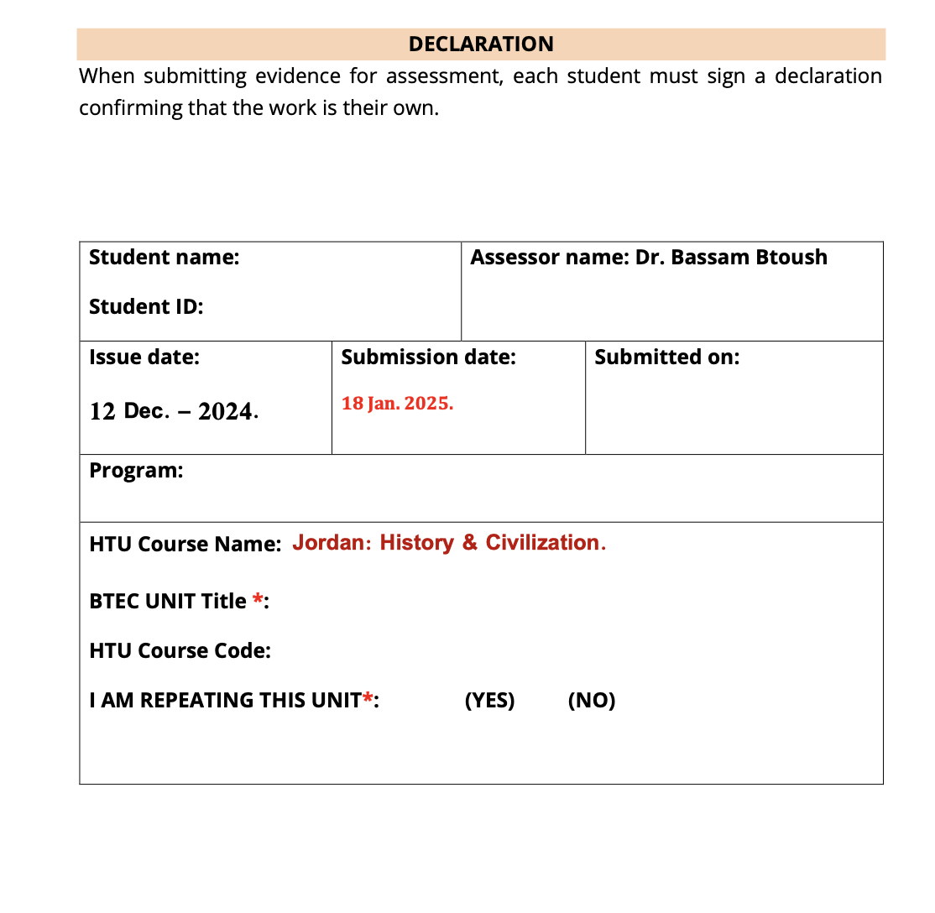



18-1-2025

Saif haddad  
21110214

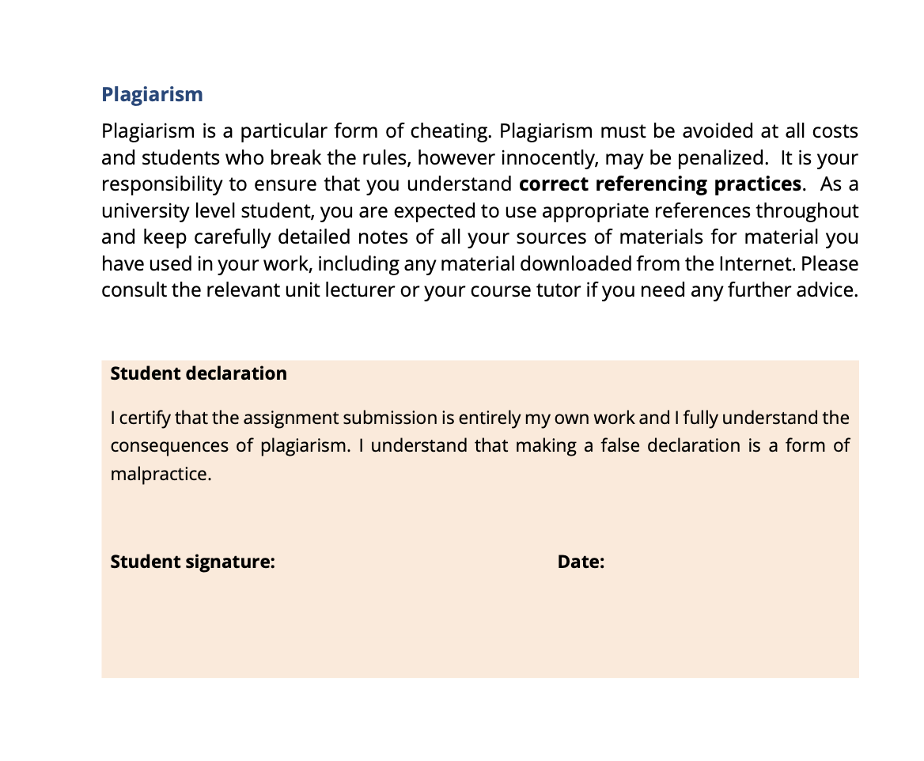

18-1-2025

Saif haddad